Hi Everyone,

Another week! So a new week, a new pack. Please download this pack so that it is easier to use. This week we will be revising and doing some new work. I will have some information from textbooks to guide you, but I have a lot of interactive activities ready for this week. I am going to give work subject by subject-if you want to organise it into each day please do. Everyone has different experiences in their houses at this time, so go at your own pace. We will be using youtube and twinklgo.

PLEASE ENSURE YOU ARE WITH AN ADULT WHEN ON THE INTERNET

There will be a lot of links to websites this week. You can copy and paste them into you browser, or if it’s highlighted hover the mouse over the link , it will tell you to press CTRL and click the link, it will automatically open it in a browser

Remember—if you copy and paste in www.viewpure.com , there will be no ads…

Ok ..

English
-reading . Everyone is going to up a stage in big cats. I am going to give specific books. There will be other books available, which we will do over the next few weeks. I know you don’t have your books, but we can read them online-if you have difficulty with words they can be read to you, it’s an interactive site.
Here’s the fun bit..

How to access free Collins Big Cat ebooks
Go to Collins Connect and click on the Teacher portal and enter:
Username: parents@harpercollins.co.uk
Password: Parents20!
and click Login.
Then click on Collins big cat. You will be given a choice of readers….
All the children are in a big cats group, red, orange(yellow), blue and green. If you can’t remember which group you are in , email me! So , the big cats books all have a band that has a colour—it is not the same as your group in school. If you wish to read the book by yourself first, pause the sound otherwise it reads it to you. There is a button to the right, red, with ticks and xs-this is an interactive activity with key words

Big cats group | Red | Blue | Green | Orange/yellow
Big cats band | Orange band | Turquoise band | Purple Band | Gold Band
Book to read | Lost Sock | Brown Bear, Wilbur Wolf | Monster Maze | I’m growing a trunk in the garden
See how you go with your book
After reading your book I want you to:
Write about your favourite character and draw a picture
Tell me your favourite part of the story
Is there anything you would change in the story?

Spellings
I am going to list the 18 spellings from Jolly phonics-each of you is on different amounts, so you know what you are able to do. Your parents will be able to test you at home, but you can let me know your score by email if you wish. Top row-first 6 middle row-middle six bottom row-last six.
<ure>
capture | fixture | vulture | feature | puncture | moisture
pressure | leisure | pleasure | treasure | composure | measurement
figure | failure | conjure | mature | secure | manicure
The grammar lesson this is questions and exclamations

Go to www.ixl.com
Fill in your information
Go to English, first class L3, second class K2, third class A1
Don’t forget to check out your rewards and certificates !!

Now it’s time for a reading comprehension. This is interactive. Follow the instructions carefully! When you get to the activity there are 3 levels, you choose the level you want to do, it is a self check activity, no writing for me! It gives help also.

Go to
www.twinkl.ie/go/sign-in

it will ask you for a code: JM1305
it will bring you to a lesson that has 2 reading comprehensions on it. You can choose which one you want to do first.

Twinkl go has some free resources, but a lot of it is subscription only. We have been upgraded by twinkl so I will be able to let you play lots of the games.

MATHS
We are revising fractions-our old friends. I told you they keep coming back!! Next week I want to introduce a new topic, but we REALLY need to understand fractions first….so…lots of videos and interactive activities. I am also going to give tables revision games. If you want to look up our busy at maths online it’s cjfallon.ie We have done most of the activities, the videos listed below are very clear and very easy to understand.
The teacher is American and says fourth instead of quarter, but he means the same thing.

Ok. So place value, then fractions—watch the videos then do the activities!

The videos

Revision of Place Value

https://www.youtube.com/watch?v=T5Qf0qSSJFI

Then revision of fractions
https://www.youtube.com/watch?v=CA9XLJpQp3c

up a step ….
https://www.youtube.com/watch?v=qDc_-GTipBk

if you think you’re ready…
https://www.youtube.com/watch?v=3xwDryouw6o

I hope they help make things clearer!!

Okay off to
www.twinkl.ie/go/sign-in

code: US0681
There are 7 fractions activities (the rest are hiding at the bottom of the page!)

Here’s the annoying bit
Now…..exit out of the game --put in www.twinkl.ie/go/sign-in again -this time it takes you to the twinklgo homepage—up on the top right corner there is an outline of a person, click on that, then on logout

Then www.twinkl.ie/go/sign-in
Code: AW7036
These are multiplication activities

The activities –there are a few fractions activities-spread them over the week!
Don’t forget to revise those tables—again, spread them out over a few days

Sorry about the complications of it all-it’s because I have the account and am sharing resources.(which I’m allowed to do , but it’s this awkward way!)

Please please make sure you understand fractions as next week we will be moving on….

Music
A bit of a chillout now at the national concert hall
Sleepover at the museum
https://www.youtube.com/watch?v=kYduhFQBuS4&feature=youtu.be

Some musical adventures with the national symphony orchestra
https://www.rte.ie/culture/2019/0115/1023294-music-in-the-classroom-musical-adventures-for-kids/

Gaeilge

If you haven’t tried Duolingo yet, do!! A few mins each day-at your own level. It does phrases, basic vocabulary etc give it a try

An irish song
https://www.rte.ie/player/series/rt%C3%A9-home-school-hub/SI0000006854?epguid=IP000065952&clipguid=PI000015616

Next try www.digitaldialects.com then click on Irish
Do colours, food, animals. You learn the words first and then play a game to see how you did!

If you feel creative…..
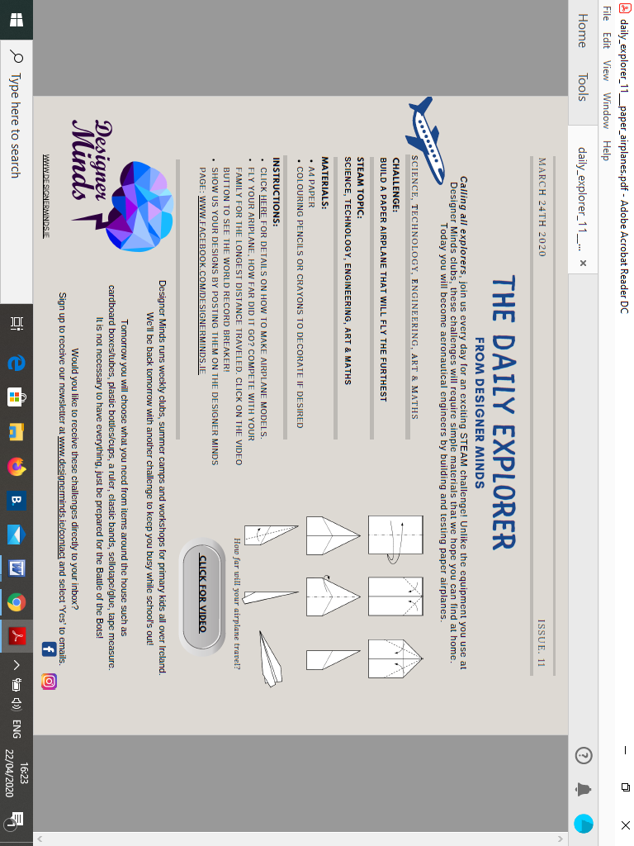

Last activity—you may like to do this one!


