Week of 25th May

My goodness, the last week of May! I can’t believe it. So hopefully everyone got their belongings back, anything left will be kept until September. All classrooms have clear tables now so a good clean can take place. The place is very strange without you guys there! I will mind your art and have it ready for you in September-it all needs to be sorted. At the end of June, all book rental books need to be returned, but any workbooks/copies can be kept.

For each week, I will give mental maths and some busy at maths. You can all work away in table toppers. I can’t remember what week we were on in mental maths-I’ll start at week 15, in case any of you have been working through it already. In class, some of you did qs 1-10 and some did qs1-20. From now on, everyone try the 1-20, do the problem of the day and then you have your Friday review. Mental maths is great for revision and it also highlights any areas you guys may be finding difficult. Remember, if there is a particular topic you find hard, use IXL to get some practice in it –go to second class and then to third class.

We have finished abair Liom, but there is a sul siar or revision section we can do. If you wish to go over any of the work, please feel free to do so. I will give pages from Bua na Cainte for revision, from edco. I will also give links to the school hub and to Irish games. It is very difficult to do Irish in isolation and I know a lot of families don’t speak irish, we’ll do our best.

In history and geography we have more or less finished our course work so we will do some revision as well as some work in our Atlas Hunt workbooks. This week we are doing a project on Poland.

Next week we are planning active week/sports day activities so that’s why the worksheets/photocopies are sports related. It’s a shorter week as there’s a bank holiday and we want you guys to have fun. If you don’t get this week’s work finished, you have next week. There’ll be activities given to try, but please don’t be putting yourselves under pressure. Remember in school we would give so much time for group discussion, group work, pair work, big cats time, sports outside, art classes etc. as well as workshops and tours. We will have to do virtual tours this year, maybe I can give links for the museum and try and put bits and pieces of videos together? If you guys would like that, I’ll give it a go!

For the students in third class.
Let me know how you are all getting on. You can email me let me know your news and how you’re doing with the work. If you are stuck on anything, please let me know. If there is anything you would like to learn more about, let me know, I’ll try my best. I miss our discussions of how we can link our subjects with our topics, and how we can present our work in different ways. If you liked the video on how to make flapjacks, it was made with adobe spark which is free, and I figured it out so you guys will be professionals! As always, anything you look at on the internet, or software you use, you need to have adult supervision. If you do make videos, please don’t put pictures of yourselves or anyone else, and no names. If you want to put your initials in the credits, check with your parents first!

PROJECT WEEK !

Our European Country is……Poland!!

I gave some sheets with your books last week, as well as a template you can use.
Either use the template and stick it into your Atlas Hunt workbook or do the project straight into your workbook. Your project on Australia was your non-European country project. You will do lots more over the coming years! More information lower on the page in geography

If you didn’t get your child’s books on Tuesday-you will need to look up the books on the publisher’s websites –they are still giving free access –I’ll list the publishers beside each book

English
Starlight: Folens
Poetry –The sound collector

Monday | Tuesday | Wednesday | Thursday | Friday
Spellings  Starlight  Read:  Qs A everyone do Q1-3  Want more? Try Q 4,5  B everyone do 1-3  Want more? Try 4,5 | Spellings  Jolly Phonics  Grammar p. 71 | Spellings  Starlight-  p. 187 C –, p. 188 D  vocabulary  rewrite sentence using the correct word-underline the new word chosen | Spellings-revise for tomorrow  Jolly Phonics  Grammar p. 188  You get to be teacher!  Rewrite the piece-without mistakes! | Test yourself on your spellings !  p.189—Read note about alliteration  twinkl go –poem  code: WS5469  If you have any work to finish from during the week, finish it off…

Spellings ‘ex’ words
exit | expect | expel | expert | extra | exist
excuse | except | explain | explore | extract | excite
excellent | expensive | example | exhibition | exhausted | examination

Irish –you need Mo lámhleabhar gramadaí—the small Irish book (I have attached answers for your parents-in the email )
Published by educate.ie

An Luan | An Mháirt | An Chéadaoin | An Déardaoin | An Aoine
Mo lámhleabhar gramadaí  Lch 25  Filling in the gaps-using verbs  Bí-be  Ith-eat  Déan-do/make  Tar-come  Feic-see | Mo lámhleabhar gramadaí  Lgh 26,27  Ar ith? d’ith mé/Níor ith  An raibh? Bhí/Ní raibh  An bhfaca? Ní fhaca  Ar thóg? Níor thóg  Ar tháinig? Níor tháinig | Mo lámhleabhar gramadaí  Lch 28,29 Q1-8  Filling in the gaps | Mo lámhleabhar gramadaí  Lch 34,35  Back over numbers…..  Special words for people  Beirt-2  Triúr—3  Ceathrar-4  Numbers for things  Dhá -2  Ceithre-4 | Mo lámhleabhar gramadaí  Lch 36  Using the phrases top of the page to help—is maith liom, Is breá liom, Is aoibhinn liom…….  (page 26 has some of the vocab to help you with the food!)

A guide to verbs An Mháirt

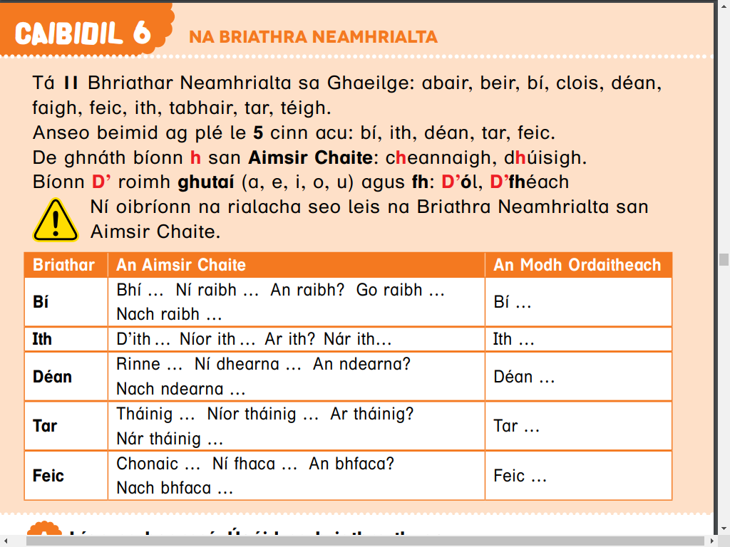

Verbs-An Chéadaoin
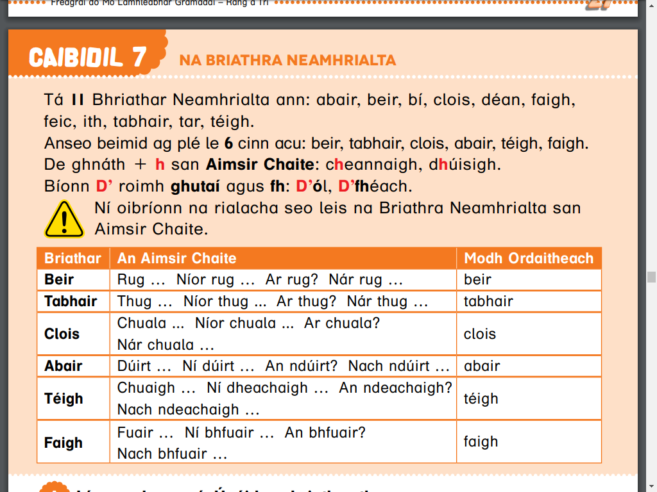

An Aoine

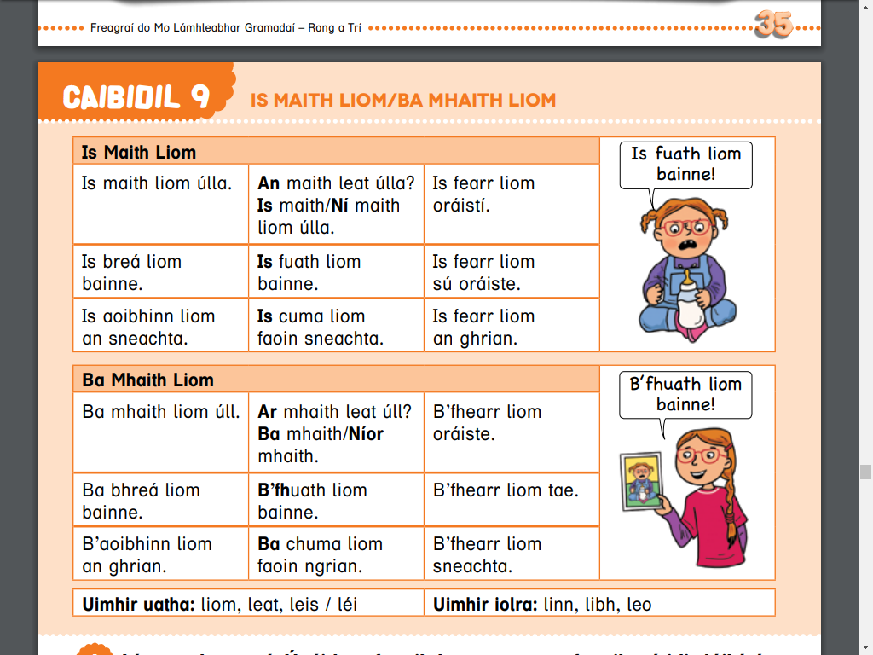

Maths Busy at maths—cj fallon Mental maths prim-ed Table toppers
I have attached answers for parents!! (in the email )
Monday | Tuesday | Wednesday | Thursday | Friday
Mental Maths week 15 Monday  Q 1-20  Monday  Busy at maths  p. 137  Division with remainders  When we divide e.g 28 /7 =4 –it means we divide 28 into 7 groups and we have 4 in each group—it divides evenly  Sometimes though,,,we may may leftovers!  10 divides by 3—3,3,3 =9  I can get 3 equal groups of 3. but I have one left over—it is called a remainder  Q4.a,b,c.  Different ways we can write our division sums…we use R for remainder…… | Mental Maths week 15  Tuesday  Q 1-20  Busy at maths  p. 137  Q 4 d,e,f | Mental Maths week 15  Wednesday  Q 1-20  Busy at maths  p. 138  Division with remainders-subtraction method  Q.1 a,b,c | Mental Maths week 15  Thursday  Q 1-20  Busy at maths  p. 138  Q2,3,4 | Mental Maths week 15  Friday review  Q 1-20

Music
Music | https://vimeo.com/245450925?mc_cid=5828bac33b&mc_eid=333ec1db79  Peter and the Wolf by the Vancouver Symphony Orchestra  (I think I may have given you something about Peter and the wolf before, if I have, apologies)  https://www.youtube.com/watch?v=iiK6MilSy7s&list=PLMaUTJmggA4YjjzZ_t0NcbTRhpHT7KnNY&index=2  It’s a hard knock life from Annie (recorded at the 2013 Tony Awards)  https://www.youtube.com/watch?v=qkHV6THFoDs&list=PLMaUTJmggA4YjjzZ_t0NcbTRhpHT7KnNY&index=7  Supercalifrajalisticexpialidocious (I hope I spelt it correctly!!) from Mary Poppins (Broadway)

Geography –2 weeks to do this
Project on Poland
Look at atlas –p. 44-can you find Poland on the map? Can you find facts on Poland p.44
Atlas Hunt –workbook –p. 38,39. Draw a map of Poland (use your Atlas)
p.39—capital city, population, language, currency etc
There is an information sheet in with your bag of books you collected from school last week. Remember to have a grown up supervise you looking on the internet—fill in information straight into the workbook

For those of you who did the project on Australia-you can stick parts of your project in on p. 54 and 55 of the atlas hunt—that’s where we would have done our project!

If any of you didn’t get to do the project-you can catch up and do it here on p.54 and 55

You will be doing projects in geography on may countries in the next 3 years and the go into this book

Don’t go ahead in this workbook as you will need it for the next 3 years…..!!!

