Scoil Phádraig St. Patrick’s N.S. Baile Mhuiris Morristown

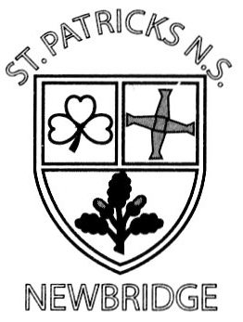

Droichead Nua Newbridge

Co. Chill Dara Co. Kildare

Fón : (045) 432446 Tel : (045) 432446

Facs : (045) 438218 Fax : (045) 438218

[www.stpatscofi.ie](http://www.stpatscofi.ie) Roll No. 13328I E-mail: scopadnua.ias@gmail.com

Principal : Joe. O’ Connor Deputy : Nicola Cole

Teacher: Ms. Laura Malone

**First Class Book List 20/21**

All Write Now Pre Cursive (Folens)

Starlight 1st Class Skills Book (Folens)

Starlight1st Class Combined Reading and Skills book (Folens)

Maths Time 1 (Edco)

Busy at Maths 1 (C.J. Fallon)

Folens Explorers SESE 1st class (Folens)

Abair Liom C (Folens)

Jolly Grammar 2 Pupil Book

These books are available to purchase in Farrell & Nephew Book Shop and Easons.

**Please mark your child’s name clearly on the front of each book.**

- Reading folder: **Plastic A4 button Folder**

-Homework Folder: **A4 Mesh Zipped folder**

- A4 Cardboard Document Wallet

Copies:

- 2 Project copies: Size 15A

- 3 Writing copies: Size A12

**Please ensure that your child has the following for September:**

**Please mark your child’s name clearly on all belongings**

Writing Pencils Rubber/ Eraser

Sharpener Colouring Pencils

2 Pritt Stick

**SCHOOL ESSENTIALS**

**School Essentials is €70 per pupil to be paid to the school by Friday 25th September**

**Please pay on line through Aladdin Connect where possible, as card payments are encouraged due to Covid 19. The school aim is not to handle cash in the future.**