Hello 1st class pupils and parents,
Well done everyone on getting this far! You are doing amazing! This is the final pack of activities for 1st class in 2019/2020. I am so thankful to you all for everything you have done over the last few months at home. I know it probably hasn’t been easy some days, but you have really impressed me with everything both you, your children and your families have done.
This work pack contains:
- Virtual School tour
- Suggestions of games/activities from the children in 1st class
- Some Maths/English/Irish games to keep our brains going
- Some Art/Music/PE games and activities
- Draw/write about your favourite memory from 1st class
- Some general fun things to do
- Colouring picture
I still can’t believe it is the last week of school for this year! As always, try your best with this pack and do what you can! I hope you enjoy it and have a fun time with your families. I can’t wait to see photos of all the activities and games that you try out. Let me know how you get on via 1stclassstpatsns@gmail.com. Just a tip for anyone wishing to do additional work in textbook, just remember that the Jolly Grammar book is kept for 2nd class!
Reminder: I am hoping to have a Zoom Call next Thursday at 2pm. During the Zoom call, we can share our favourite memories of the last year (using the idea from the work pack). Also, you could bring your favourite teddy along too! I am really looking forward to it. Please let me know if your child is interested by 2pm on Wednesday so I can send you through the link/instructions. I can’t wait to hear/see from as many of you as possible!
I want to say thank you for all your hard work, dedication, support and kindness not only over the last few months but since September. It has been such a pleasure to be your child’s teacher! They are an amazing, talented and kind group of children! I know they will do great in 2nd class. Enjoy the summer! Read, get outside for fresh air every day and take time to relax!
Enjoy the ‘last week’ of 1st class! I hope you enjoy the activities and games! Remember I am here if you have any questions about them. I will be in touch via email until the end of term!

Stay safe and take care!
Best wishes,
Ms. Delaney
Virtual Tour

End of year school tour is something that I was really looking forward to, I’m sure the children were also. So instead, we are going to do a virtual school tour. We have been learning about so many different animals and aquariums. So, I have decided that we could do two virtual school tours!!
Remember when you go on a school tour, you must remember the following things:
- Pack a snack! (You could use your lunch box/bag like in school)
- Make sure you get there on time (These links are available all the time but better at certain times)
- Enjoy! (This is the most important!)

First Destination: Dublin Zoo
Second Destination: Monterey Bay Aquarium

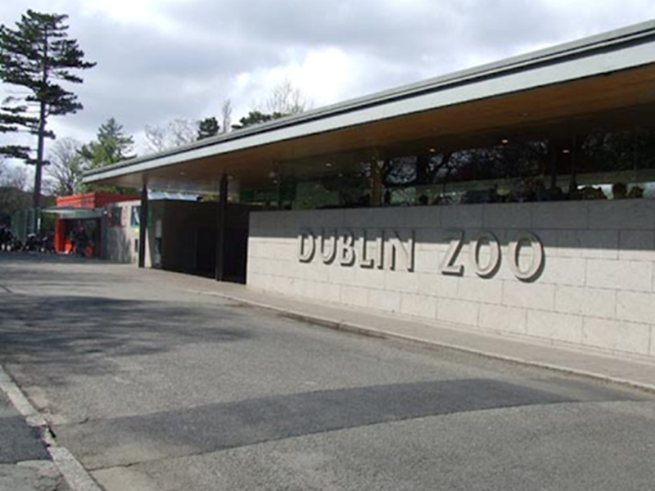
Dublin Zoo:
https://www.dublinzoo.ie/animals/animal-webcams/ (Live Animal Webcams)
There are facts available also about each of the animals too. These are live webcams so they may take a few minutes to start up.
You could go on your virtual tour on Monday if you like. (If this day does not suit, you could do it on Wednesday)
Penguins: begin to get hungry at 2:30pm so this is probably a good time to watch them! They can be seen at other times too.
African Savannah: the giraffes and some of their friends can be seen here.
Elephants: the best time to view the elephants is at 10:30am and 12:30 pm.
So here is a suggested schedule:
Monday:
9:30 – Make your snack!
10:25 – go on to link with a parent/adult!! (Tickets are below)
10:30 – Elephants
11:30 – Have your snack and play a game!
12:30pm – Elephants!! (Draw what you can see!)
2:30 – Have a look at the penguins! Talk about your day with your family! Tell them about all the animals you saw. Which one was your favourite?

Virtual School Tour to Dublin Zoo:
Name: ___________
Today is _________________________.
I went to _______________________.
I saw___________________
__________________________________________________________________________________________.
Draw a picture of you at Dublin Zoo!

Our class quite like wordsearches so I have included one here about zoos:

https://www.twinkl.ie/resource/roi-l-928-whos-at-the-zoo-word-search
Monterey Bay Aquarium
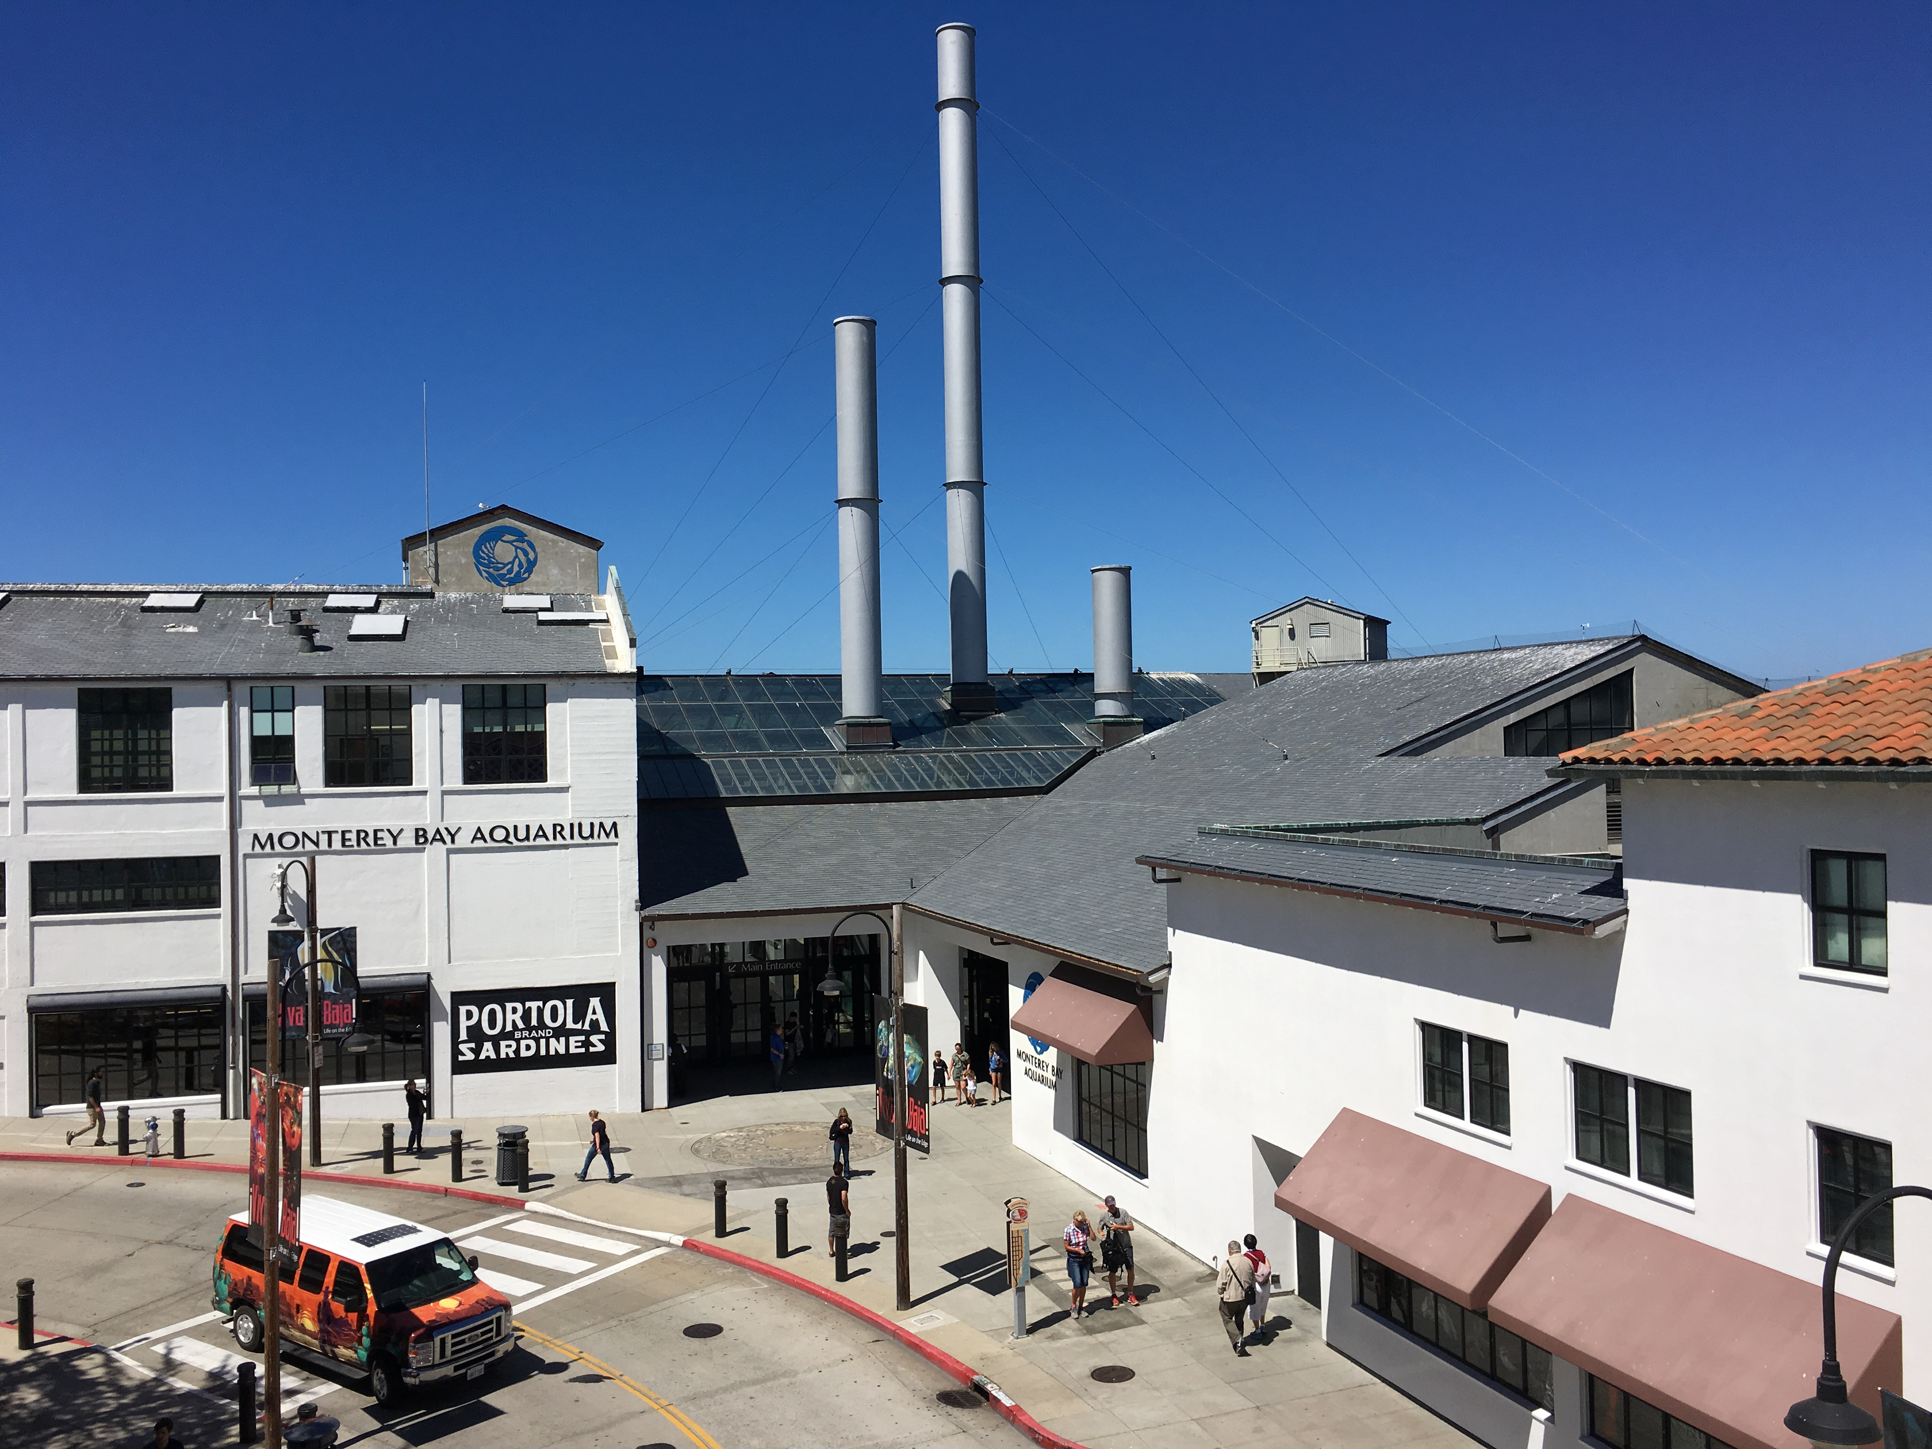
This aquarium is in California. That is America.
So you will have to take a (pretend) flight
Link to the aquarium - https://www.montereybayaquarium.org/animals/live-cams
As it is in a different time zone, the best ones to watch are the cams below. These are pre recorded and can be watched at any time. Children should have an adult with them.
Schedule for Tuesday (or choose a day of your choice)
9:30 – 10:00 Make your snake for the aeroplane!
10:00 – 10:30 Turn a seat in your house into an aeroplane and enjoy the flight (Aeroplane tickets and aquarium tickets are below!)
11:00 – 11:15 – Have a look at the sea otters!
11: 30 – 11:45 Take a look at the coral reef cam!
12:00 – 12: 30 Have some lunch!
1:00-pm – 1:30 Have a look at the Jelly Cam and the Moon Jelly Cam!
1:30 – 2:00pm Have a look at the Penguin Cam!
2:00pm – Your flight back to Ireland (pretend)! Tell your family about your busy day!
Virtual School Tour to Monterey Bay Aquarium:
Name: ___________
Today is _________________________.
I went to _______________________.
I saw___________________
__________________________________________________________________________________________.
Draw a picture of the animals you saw!

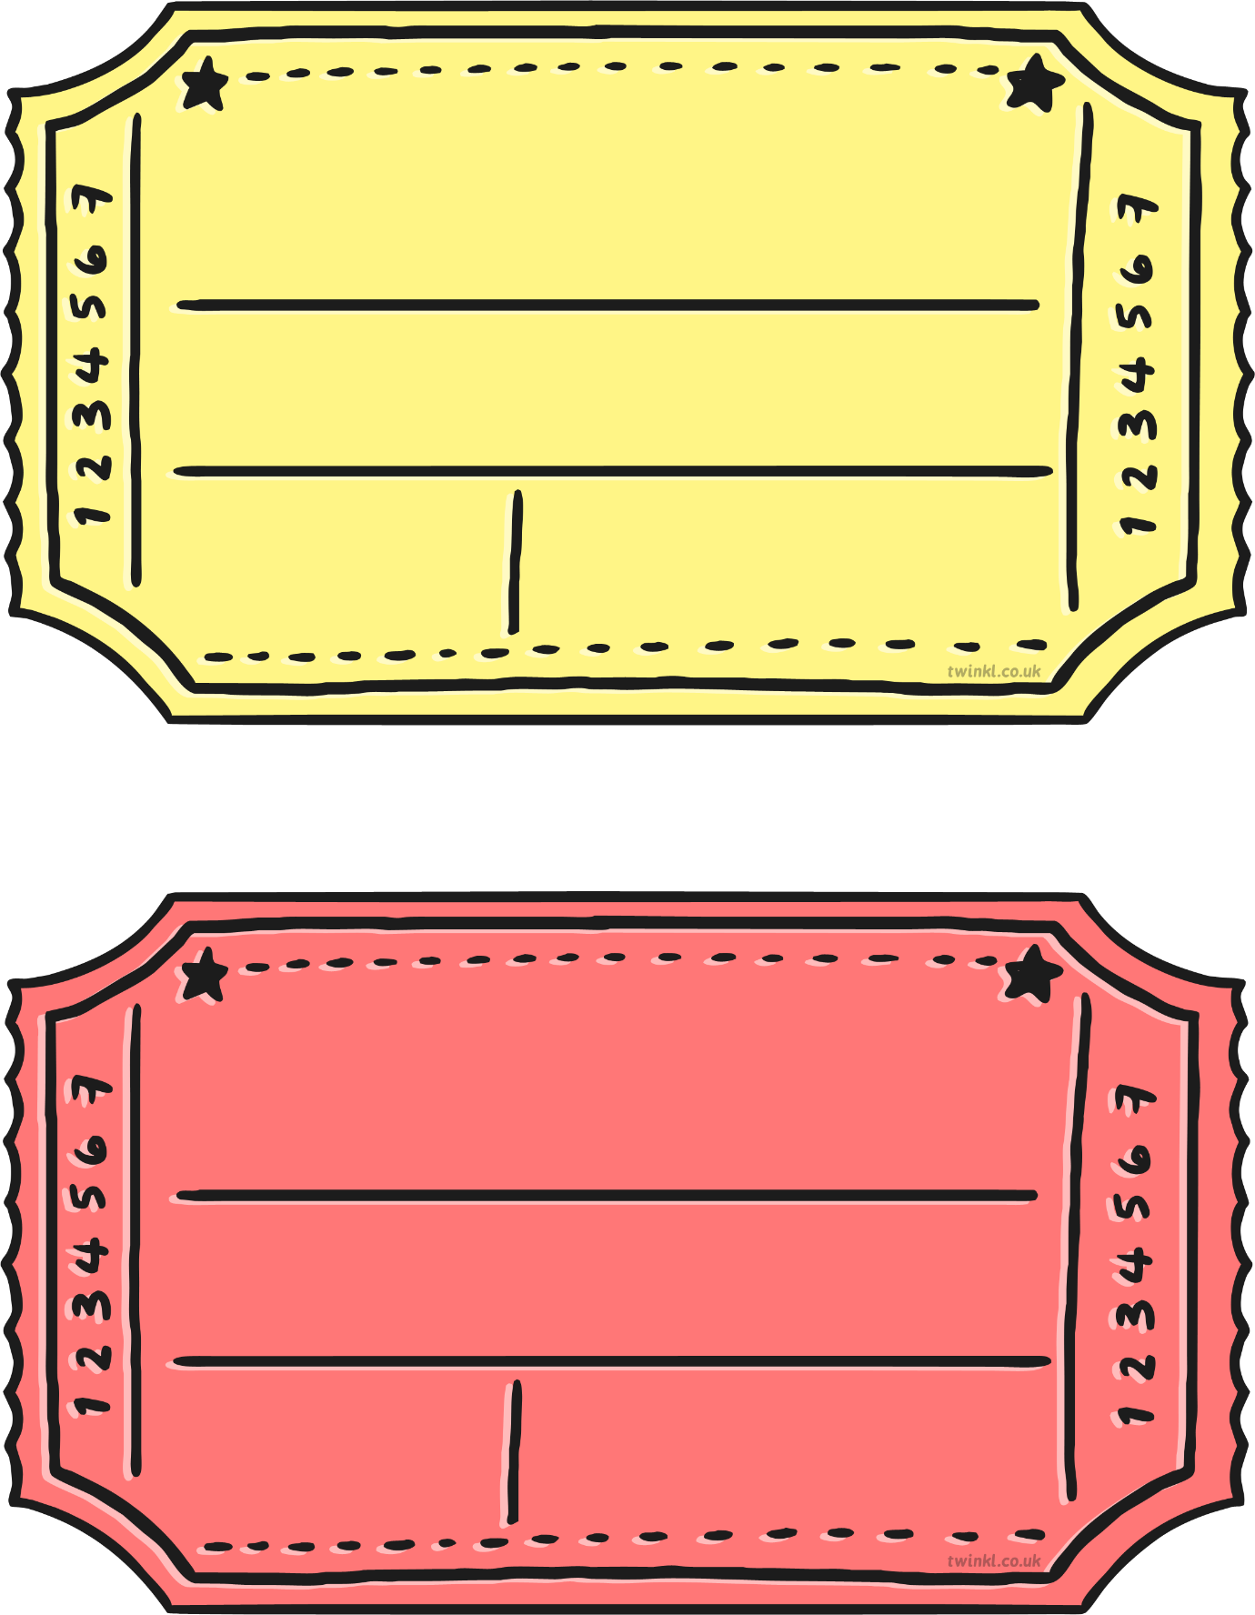
1st class St. Patrick’s NS
End of year school tour

Enjoy the day!
Day pass to Dublin Zoo
1st class St. Patrick’s NS
End of year school tour
Enjoy the day
Day pass to Monterey Bay Aquarium

Template – Twinkl and edited by Ms. Delaney

1
11am
10am
Aquarium
€0
1STCLASS
STPAT123
123456
This is a screenshot from Sparkle box website and edited by Ms. Delaney

Some of our favourite activities!
(These are ones that the pupils in our class suggested last week)
- Colour by numbers
https://www.twinkl.ie/resource/t-t-11618-summer-themed-colour-by-number (More available at this link )

- Gymnastics (PE)
https://www.twinkl.ie/resource/t-pe-42-ks1-gymnastic-shapes-fortune-teller
This is a fortune teller (It tells you which instructions to use) I have a screenshot here also. Make sure an adult is with you when you do these activities.
You could also make your own PE fortune teller with your favourite activities. Just make sure you have a square piece of paper.

- Art
Some ideas for you to try:
- Why not either draw around your hand/ paint your handprint on the page.
Draw or paint about you and your family
Keep it somewhere safe until your old.
It will be like a time capsule!

- Running
Our class are super at running and enjoy it.
Here are a few running activities/games:
- Use a line (Could be one outside your house/ draw with chalk or mark with something)
Run along the line – Can you stay on the line??
- Traffic lights – some calls out red (Stop), orange (slow down) or green (go fast) and the child follows the instructions.
- Tag
- Races
I have been doing some jogging over the last few months too!
Keep being active!

- Zones
First Class enjoyed learning about the Zones of Regulation this year.
Why not teach your family all about the different zones?
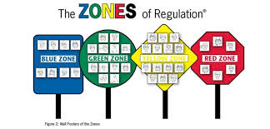

Here are some fun Maths activities:

English/Irish games:
- Here are some links which have fun games

- https://www.twinkl.ie/resource/t-s-891-what-am-i-guessing-game-cards-food-themed
- https://www.twinkl.ie/resource/t-t-12241-summer-read-and-colour-worksheet
- https://www.twinkl.ie/resource/t-a-022-summer-activity-pack
- Read as much as you can! Let me know what you’re reading! I have heard you are doing great reading. Some children in our class are reading Horrid Henry and Harry Potter and other books they enjoy!
- Irish wordsearch
- An acrostic poem about summer

Experiments and Investigations

Scavenger Hunt for Outside on the dry and sunny day!
Think about what you would like to be when you grow up! Get your parent to take a photo and keep it in a safe spot. Have a look when you get older!

Some Art ideas:
This is an idea I saw. It is masking tape and then a collection of flowers on top. It is lovely way to make something out of nature.

Breathing Wand
- Take a toilet paper roll and cut off the top.
- Cut a straight line all the way up the remainder of the roll.
- Use this cut to tighten up the roll to roll it thinner and tape on top and bottom to hold it in place.
- Decorate the roll with paint, markers, stickers etc
- Tape strands of thin ribbon/paper along the inside of the small ring you cut off earlier.
- Tape the ring on top of the thinner roll to make the wand.
- Breathe and notice what you notice.
An idea from Pinterest!
Make a face (it could be your face) out of different materials!

Why not make some yummy icepops?
You could make them out of colourful paper/paint/markers/colours.

Music (Songs and activities):
Some of the songs which we learnt this year:
- You’ve got a Friend in Me (Toy Story) - https://www.youtube.com/watch?v=EcXURC_nNhc
- Jesus’ love is very wonderful (from our church assembly)
https://www.youtube.com/watch?v=WcgplHIntJc
- Our God is a great big God
https://www.youtube.com/watch?v=eaXPXWBcE3I
- Báidín Fheilimí
https://www.youtube.com/watch?v=iWS2h_CmdOY
- Lá ‘le Pádraig, Lá ‘le Pádraig (Goes to the tune of the link below)
https://www.youtube.com/watch?v=zYsrgKJX6Js
Lyrics:

- Why not have a family disco? You could put on some of your favourite songs and dance around and sing along.
Here are a few suggestions but I am sure you have plenty:
https://www.youtube.com/watch?v=g_3xM0rEnLI&t=26s (The Macarena)
https://www.youtube.com/watch?v=KhfkYzUwYFk (Can’t Stop the Feeling)
https://www.youtube.com/watch?v=2UcZWXvgMZE (Freeze Song)

**Tip** The emoji face is laughing

PE Activities:
- Joe Wicks is on Monday/Wednesday/Saturday from 9am https://www.youtube.com/watch?v=Y_SYhZ269HE
If your child has been doing this, there is a free certificate available below the video on YouTube!
- So many of you have been going for walks, runs, cycles and have been dancing. Keep that up and keep being active!
- Here are a few games that we played in PE during the year that you could teach your family
- The bean game
- Clusters (all running/skipping etc around and a number is called out and they have to get in to that group)
- Simon says
- Shipwreck
- Challenge: design an obstacle course. I have a few ideas for you below. Time yourself!

Here are a few links from Pinterest which have good ideas for obstacle courses at home:
- https://www.keepcalmandmommyon.com/make-your-own-kids-obstacle-course/
- https://www.tootsmomistired.com/sidewalk-chalk-obstacle-course/
Keep trying GoNoodle!
Did you enjoy the Cosmic Yoga last week? Here is a link to some more videos.
https://www.youtube.com/user/CosmicKidsYoga

So, this is our last pack before the end of a year! This is the perfect time to think about all you have learnt, memories you have made and all the friendships you have!
Below, I have a worksheet about your favourite memory in 1st class. You can write, draw and colour. Talk with family about different activities, special days and lessons we have learnt.
I have so many lovely memories with you all
Here are some of the fun times we had in 1st class 2019/2020:
- First day in 1st class
- Halloween (Dress up Day)
- Volleyball
- World Book Day activities (Dress up)
- Our Class Assembly (Advent)
- Singing for Ms. Kingston’s retirement
- Breaktime
- Movie Day
- Learning about Australia
- Doing Maths investigations like measuring etc
- Maybe you read a lovely book
- Maybe you learnt something new that you did not know before
- Singing songs in the classroom
- Visit from Santa
- Assembly with Mr O’Connor
- Assembly with Reverend Tim
- Junior Assembly
- Making our tricky words in playdough/on mini whiteboards
- Art – Valentine’s Day/Christmas/ Painting the rocks
- Golden Time – pick one thing you enjoyed
- Building the Great Wall of China
- Teddy day (reward from filling our kindness jar)
- Meeting Elfie Joey (Our elf on the shelf)

** Tip: you don’t need to print out the next page. You can just draw and write and put the same title**

Please send a photo of it when you complete it

1st class
2019 – 2020
My favourite memory

Some general fun activities you could with your family:
- Have a movie day (Pick your favourite movie and watch with them)
- Have a picnic (with careful distancing)
- Go for walks/runs
- Play board games
- Read every day!

Thank you everyone! Have a brilliant summer!

